**ROLDA, Christine Mae B. Rolda**

BSIT-2 (BLOCK A)

**ACTIVITY: ARRAY AND FUNCTIONS**

* **Source Code (array_functions.php):**

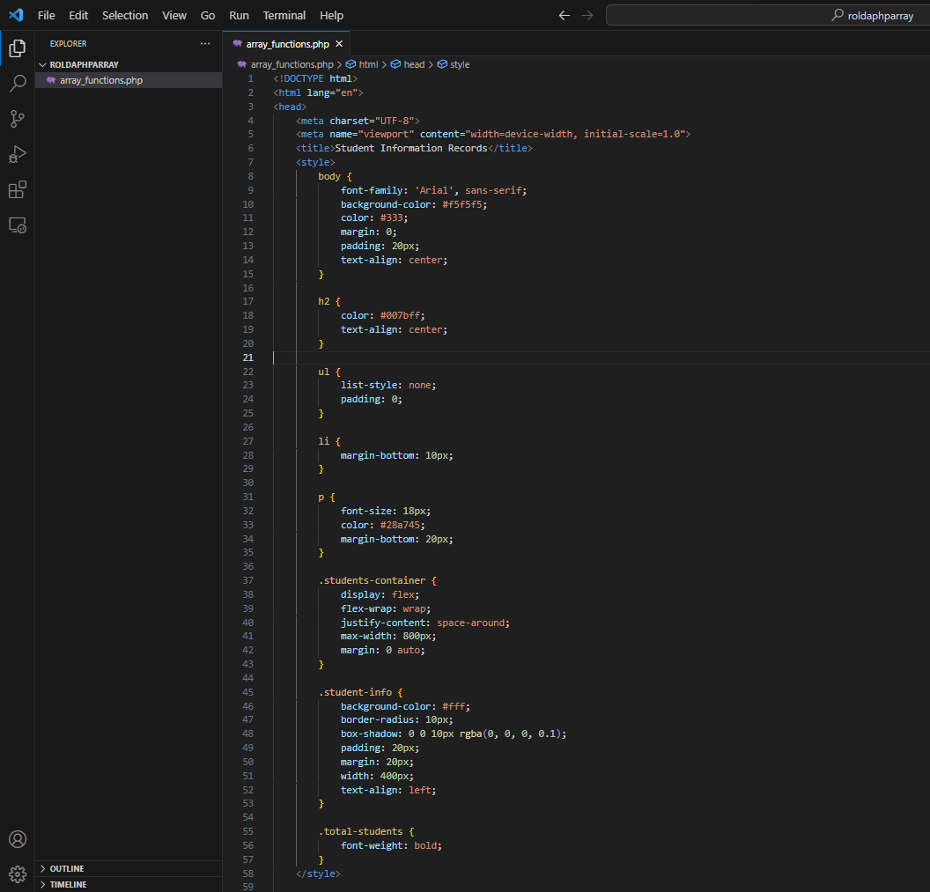

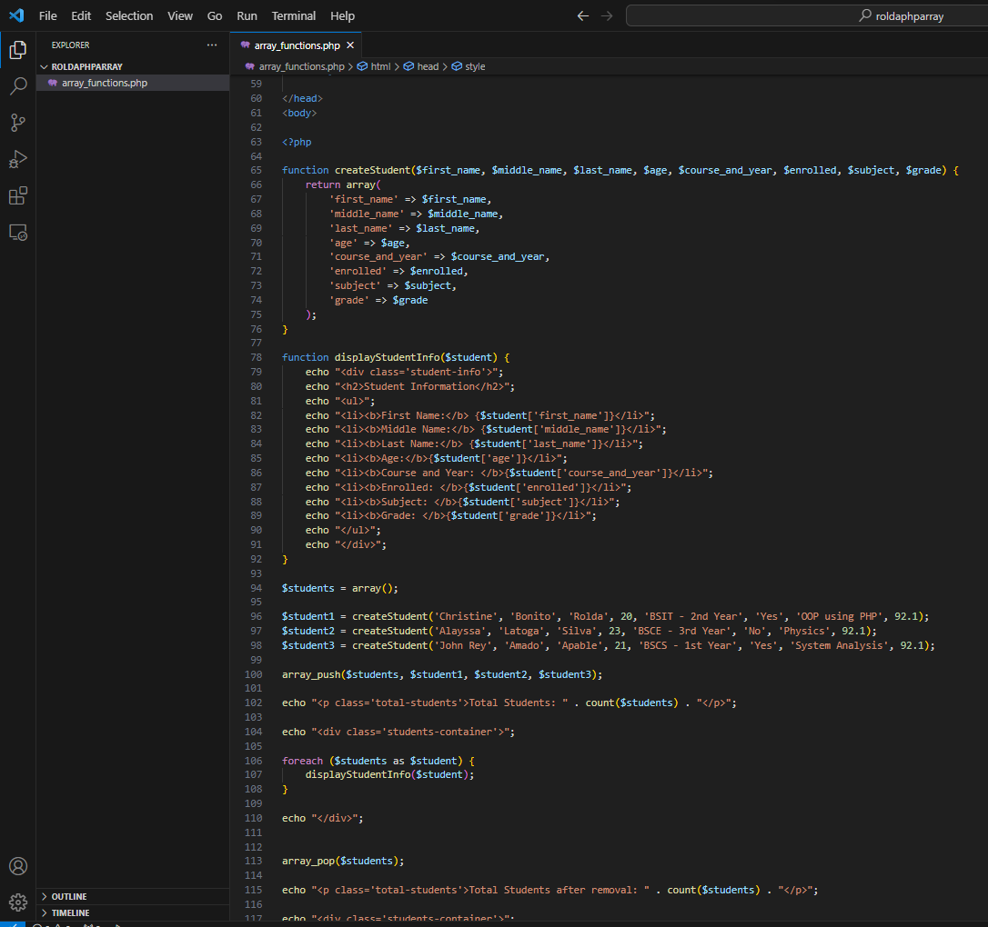

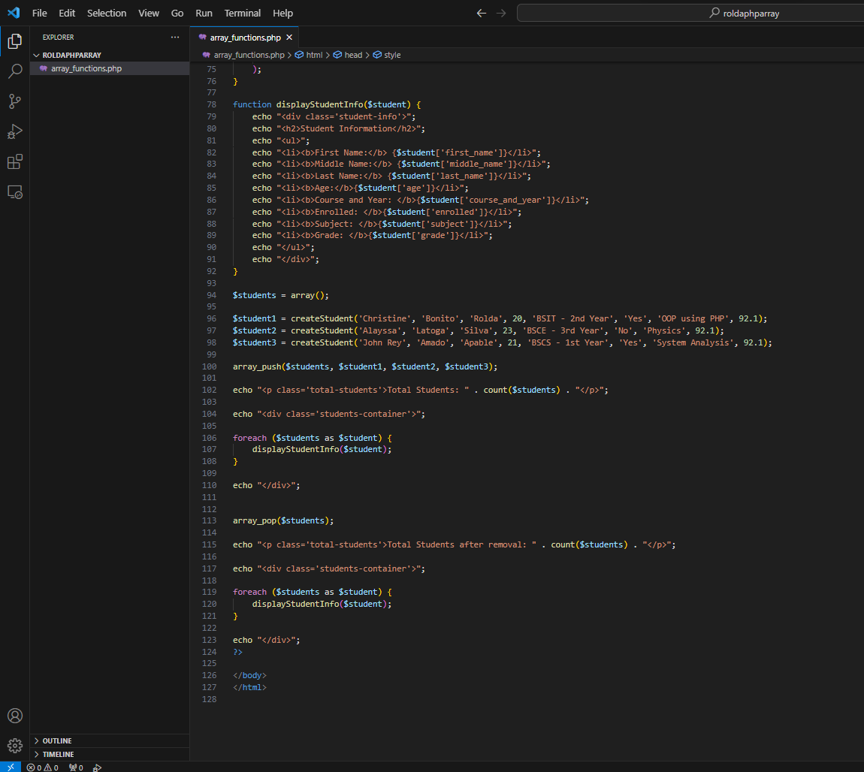

* **Output:**

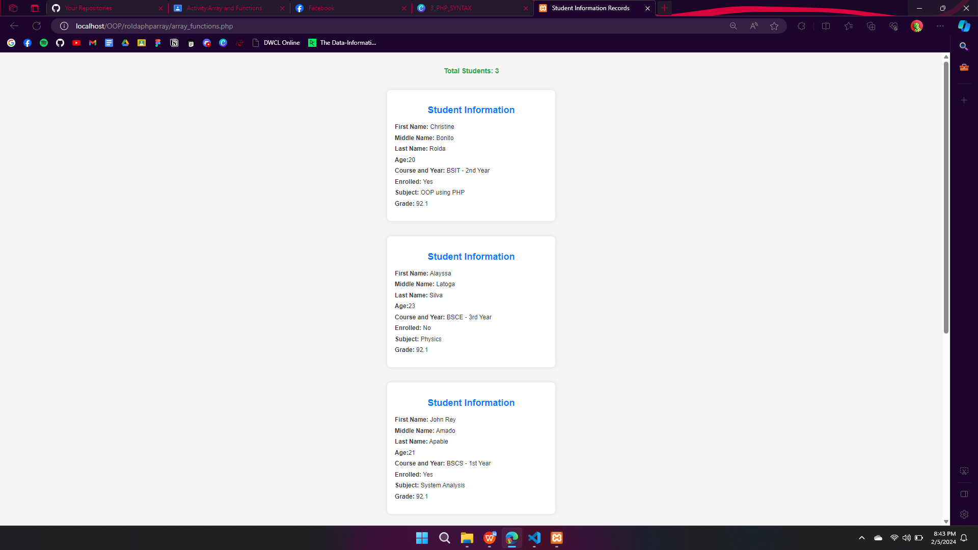

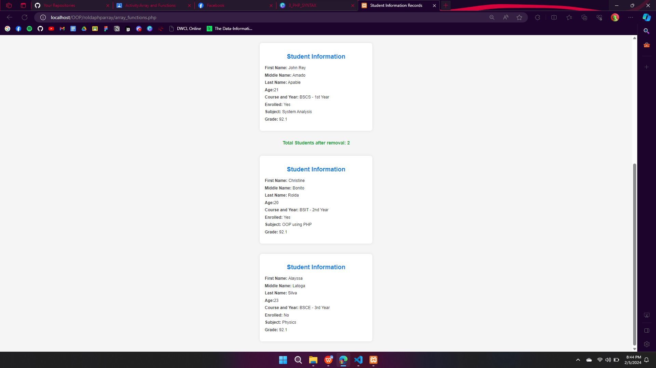

**FILE AND FOLDERS UPLOADED TO GITHUB:**

**Link:**

**ALL SOURCE CODES FOR ARRAY AND FUNCTIONS:**

* **Source Code (array_functions.php):**

<!DOCTYPE html>

<html lang="en">

<head>

<meta charset="UTF-8">

<meta name="viewport" content="width=device-width, initial-scale=1.0">

<title>Student Information Records</title>

<style>

body {

font-family: 'Arial', sans-serif;

background-color: #f5f5f5;

color: #333;

margin: 0;

padding: 20px;

text-align: center;

}

h2 {

color: #007bff;

text-align: center;

}

ul {

list-style: none;

padding: 0;

}

li {

margin-bottom: 10px;

}

p {

font-size: 18px;

color: #28a745;

margin-bottom: 20px;

}

.students-container {

display: flex;

flex-wrap: wrap;

justify-content: space-around;

max-width: 800px;

margin: 0 auto;

}

.student-info {

background-color: #fff;

border-radius: 10px;

box-shadow: 0 0 10px rgba(0, 0, 0, 0.1);

padding: 20px;

margin: 20px;

width: 400px;

text-align: left;

}

.total-students {

font-weight: bold;

}

</style>

</head>

<body>

<?php

function createStudent($first_name, $middle_name, $last_name, $age, $course_and_year, $enrolled, $subject, $grade) {

return array(

'first_name' => $first_name,

'middle_name' => $middle_name,

'last_name' => $last_name,

'age' => $age,

'course_and_year' => $course_and_year,

'enrolled' => $enrolled,

'subject' => $subject,

'grade' => $grade

);

}

function displayStudentInfo($student) {

echo "<div class='student-info'>";

echo "<h2>Student Information</h2>";

echo "<ul>";

echo "<li><b>First Name:</b> {$student['first_name']}</li>";

echo "<li><b>Middle Name:</b> {$student['middle_name']}</li>";

echo "<li><b>Last Name:</b> {$student['last_name']}</li>";

echo "<li><b>Age:</b>{$student['age']}</li>";

echo "<li><b>Course and Year: </b>{$student['course_and_year']}</li>";

echo "<li><b>Enrolled: </b>{$student['enrolled']}</li>";

echo "<li><b>Subject: </b>{$student['subject']}</li>";

echo "<li><b>Grade: </b>{$student['grade']}</li>";

echo "</ul>";

echo "</div>";

}

$students = array();

$student1 = createStudent('Christine', 'Bonito', 'Rolda', 20, 'BSIT - 2nd Year', 'Yes', 'OOP using PHP', 92.1);

$student2 = createStudent('Alayssa', 'Latoga', 'Silva', 23, 'BSCE - 3rd Year', 'No', 'Physics', 92.1);

$student3 = createStudent('John Rey', 'Amado', 'Apable', 21, 'BSCS - 1st Year', 'Yes', 'System Analysis', 92.1);

array_push($students, $student1, $student2, $student3);

echo "<p class='total-students'>Total Students: " . count($students) . "</p>";

echo "<div class='students-container'>";

foreach ($students as $student) {

displayStudentInfo($student);

}

echo "</div>";

array_pop($students);

echo "<p class='total-students'>Total Students after removal: " . count($students) . "</p>";

echo "<div class='students-container'>";

foreach ($students as $student) {

displayStudentInfo($student);

}

echo "</div>";

?>

</body>

</html>